**Name**: Ahmed Badran Sayed Badran

**ID: 43**

**Group: 1**

**Section: 2**

**Topic**: Artificial Intelligence

**Application Brief**:

This field is the future and I want to know about it

**GitHub-Link:**

**GitHub-Page(Published Website):**

**Screenshots**:

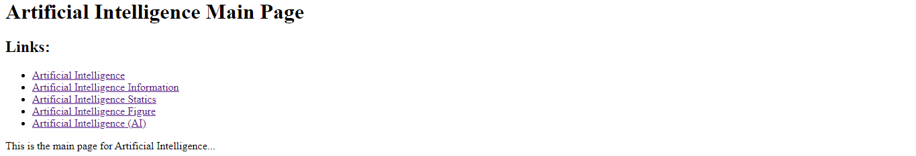

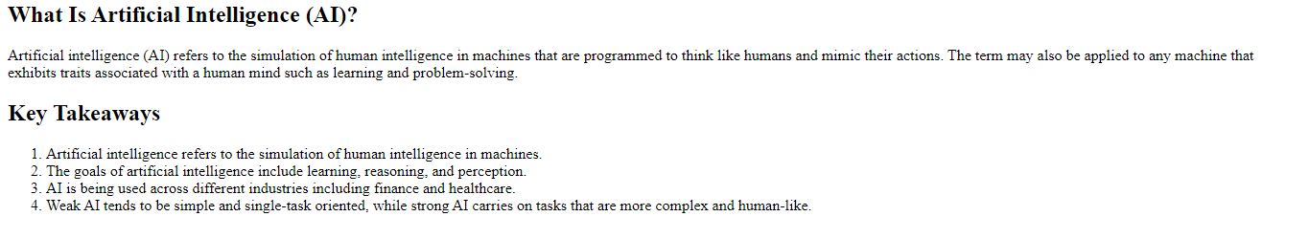



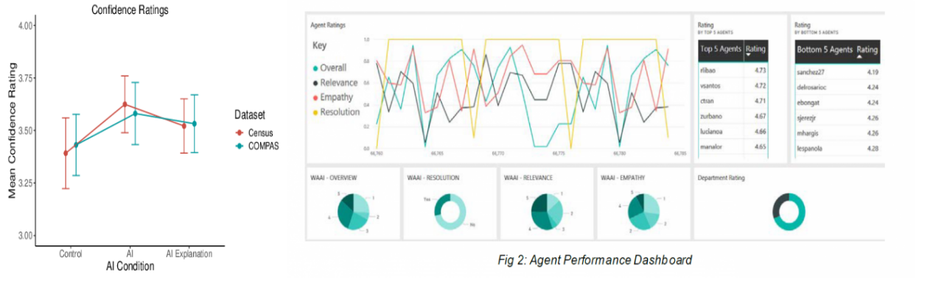

**Source Code**:

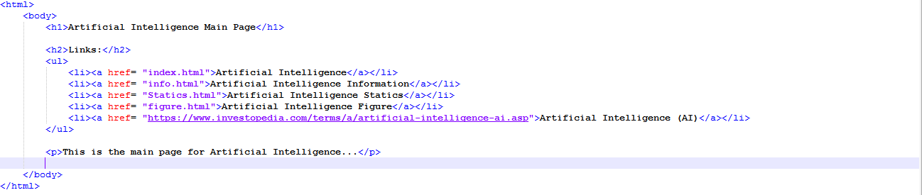

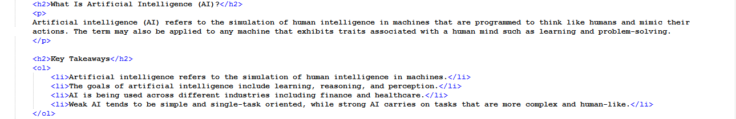

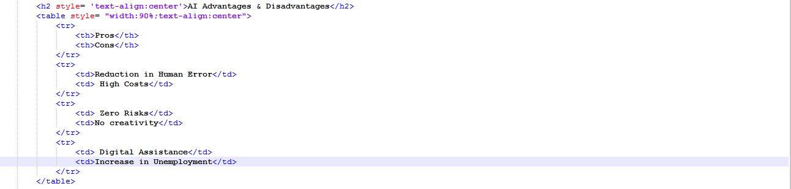

8